Chef Mike
No-Limit Catering

Pumpkin Pie Subscription
Boone’s Farm
&
the Clay-Platte
Farmessorians
We don’t know what Chef Mike and Lerry will come up with….there’ve been whispers of a cinnamon graham crust, Shatto cream, or some fragrantly remembered Iron Horse delicacy….we just know it’ll ROCK the heirloom pumpkins the kids grew this summer!
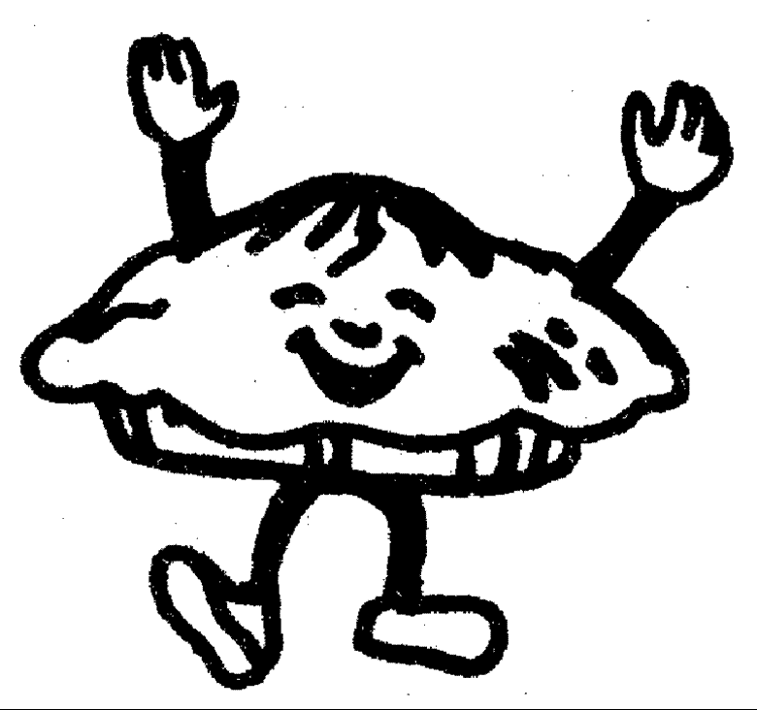
When can I have it? Right before Thanksgiving break.

What’s it cost? $20 per pie

Yes! I’d like: 1 pie 2 pies

My Total Subscription: $________________________

_____________________________________ ______________________ Check No. Amount
Signature Date
_________ _______
_____________________________________ _______________________________
Your Name Spouse's Name

_____________________________________ __________________ ________ _________
Address City State ZIP

____________________ _________________________ ____________________________
Phone Alternate Phone Email

Please return order form and payment to Lisa or Hermione at the Friday Market by Nov. 18th.

